

**PROJECT**

**“Car Rental System using C++”**

Arranged by : Group 4

|  |  |
| --- | --- |
| 1. Gafrilatif Aviandi Putra Adnanta | (2120010053) |
| 2. Muhamad Farhan Budiana | (2120010203) |
| 3. Muhammad Zidan Satrio | (2120010105) |

Faculty :

Riza Muhammad Nurman

**Continuing Education Program Center for Computing and Information Technology**

**Faculty of Engineering, University of Indonesia**

**2022**

**PROJECT ON**  
CAR RENTAL SYSTEM USING C++

Developed by

Name : Gafrilatif Aviandi Putra Adnanta

Muhamad Farhan Budiana

Muhammad Zidan Satrio

Faculty : Riza Muhammad Nurman



**CAR RENTAL SYSTEM USING C++**

Batch Code : 2ISA3

Start Date : 12 Aprill 2022

End Date : 21 Aprill 2022

Name of the Coordinator : Riza Muhammad Nurman

Name of Developer : Gafrilatif Aviandi Putra Adnanta

Muhammd Farhan Budiana

Muhammad Zidan Satrio

Date of Submission : 21 Aprill 2022



**CERTIFICATE**

This is to certify that this report, titled *CAR RENTAL SYSTEM USING C++,* embodies the original work done by *Gafrilatif Aviandi Putra Adnanta, Muhammd Farhan Budiana, and Muhammad Zidan Satrio* in partial fulfillment of his/her cource requirement at NIIT.

Coordinator :

*Riza Muhammad Nurman*

**ACKNOWLEDGEMENT**

Thank you, the author wishes to God the Almighty for His blessings and grace, we can complete this project task both in the form of presentation and paper in a timely manner.

The author also delivers him gratitude to Mr. Riza Muhammad Nurman faculty and other faculty for all guidance to complete it. Thank you to fellow students who have supported, and also thank you to fellow workers in the education at CCIT FT UI. The Project paper entitled “ Car Rental System using C++ ” the author submits as a requirement for the Project assignment in 2022.

Finally, the authors hope this paper can be useful for all and also gain a better insight into the operating system. The author realizes that it is still imperfect. Therefore, the authors really expect all suggestions and criticisms from readers who are constructive in order for the perfection of this paper. Hopefully, this paper can provide many benefits for the readers.

**SYSTEM ANALYSIS**

The development of existing programming methods is growing so rapidly, it is marked by the many new programming methods aimed at making it easier for programmers to do programming and various purposes. because the development of the program is getting faster, there are many system changes where many fields have been digitized, coupled with the covid-19 pandemic, making everything turn online and programmed.

This problem will not been resolved until everything is digitized in order to compete and survive in this era of development. One example is the problem of public services in car rental and other fields. In order to speed up service and maintain health protocols where we are required to change our service system to be completely digital

Therefore, we created a simple program based on object oriented programming about a car rental system as an example of a solution so that people can survive and compete in today's conditions where everything is connected to each other by the internet. In this project we created a car rental system using C++ language, and we created a simple menu where customers can rent a car easily just by going through this program without having to meet face to face.

**FLOWCHART MAIN MENU**

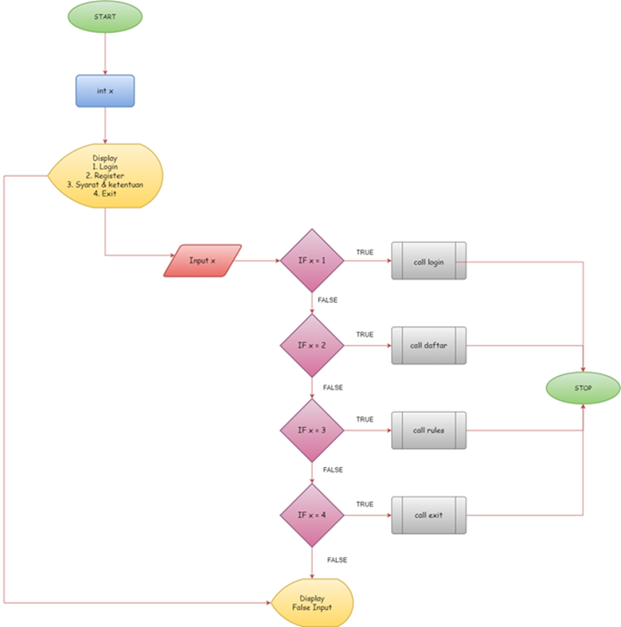

**FLOWCHART RULES**

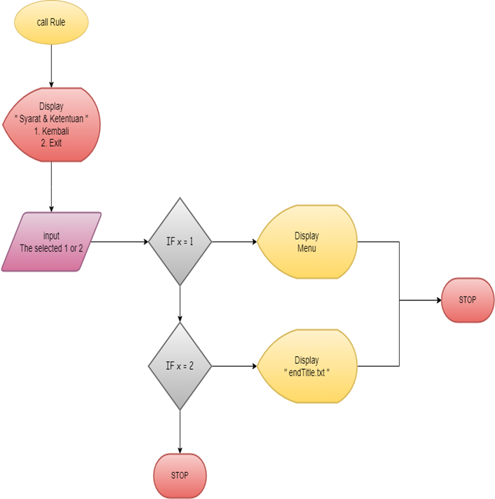

**FLOWCHART LOGIN**

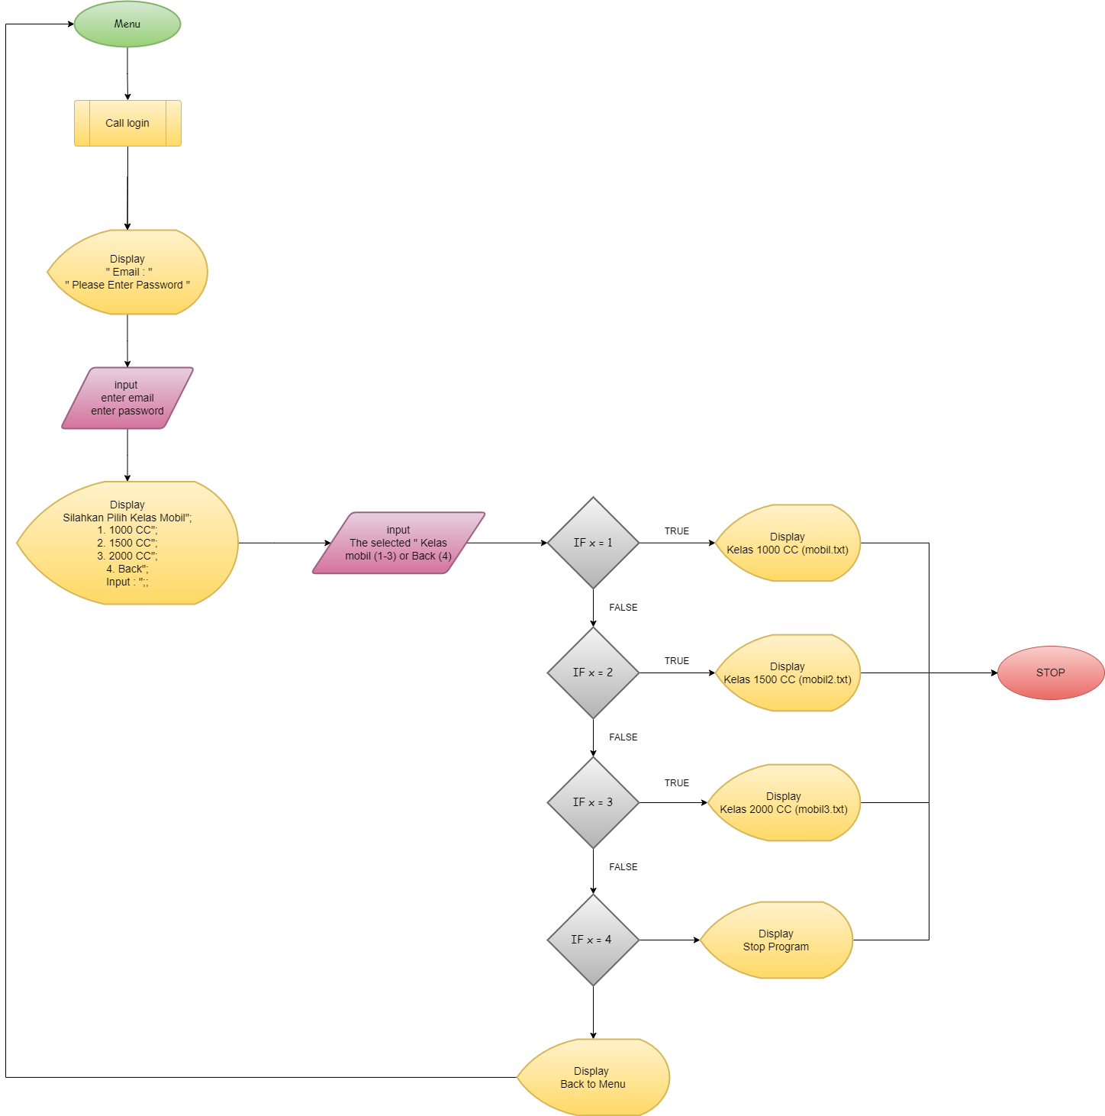

**FLOWCHART REGISTER**

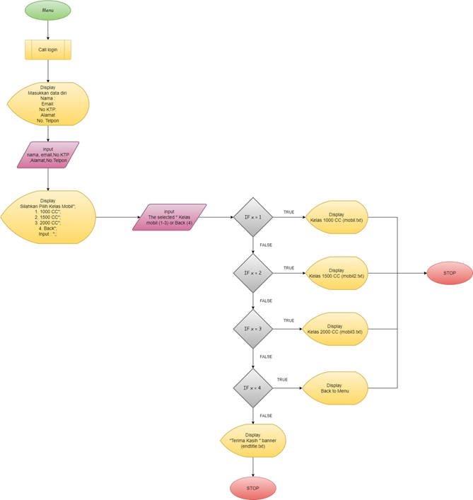

**FLOWCHART 1000CC RENT CAR**

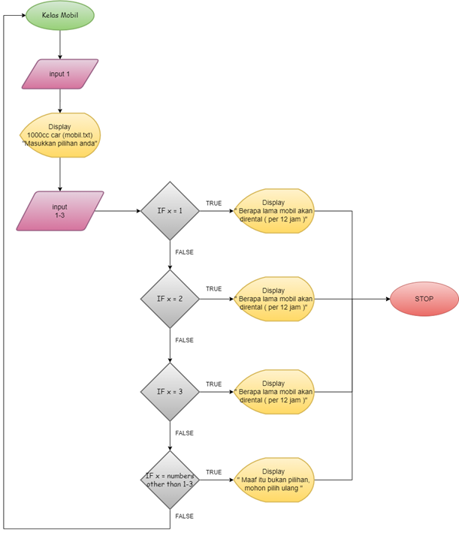

**FLOWCHART 1500CC RENT CAR**

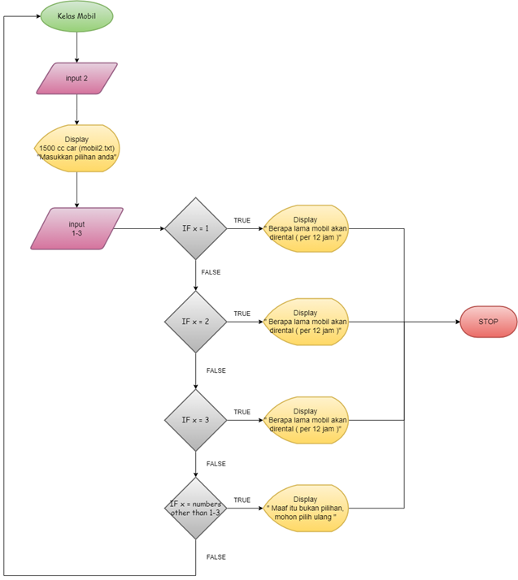

**FLOWCHART 2000CC RENT CAR**

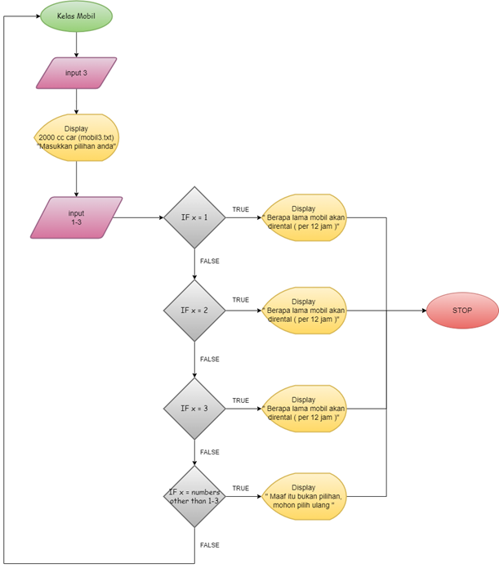

**FLOWCHART CAR INPUT TO FINAL PAYMENT**

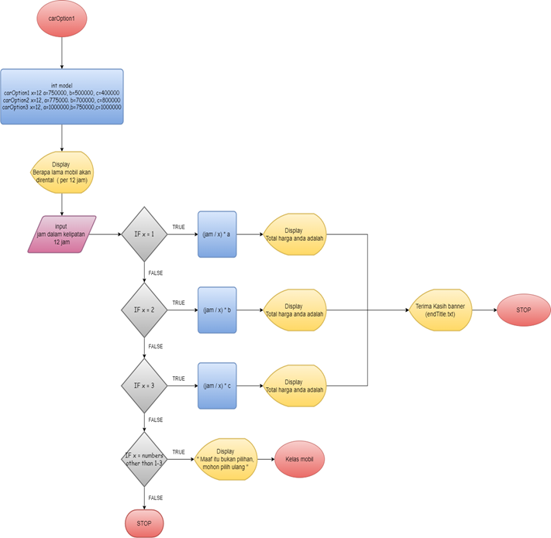

**FLOWCHART EXIT**

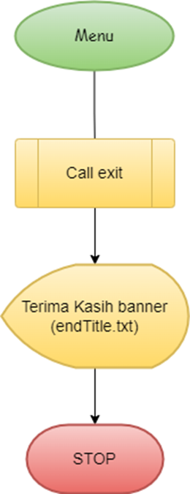

**PROGRAM CODE**

include <iostream>

#include <string>

#include <fstream>

#include <conio.h>

#include <windows.h>

using namespace std;

void menu();

void login();

void daftar();

void rules();

void exit();

void customer();

void carOption1();

void carOption2();

void carOption3();

void fullscreen();

void startdisplay();

void loading();

void gotoxy(int x, int y);

void bingkai();

void bon(long jam , long total);

**PROGRAM CODE**

class homeMenu{

public:

menu(void){

fullscreen();

loading();

int x;

string line;

gotoxy(15, 1.5);

ifstream myfile("Title1.txt");

if(myfile.is_open())

{

while (!myfile.eof())

{

getline(myfile,line);

cout << line << endl;

}

myfile.close();

};

cout << endl;

cout<< "\n\t \t\t 1. Login ";

cout<< "\n\t \t\t 2. Register ";

cout<< "\n\t \t\t 3. Syarat dan Ketentuan ";

cout<< "\n\t \t\t 4. Exit "<< endl <<"\n";

cout<< "\n\t \t\t Input : ";

cin>>x;

**PROGRAM CODE**

if (x==1){

login();

system("cls");

bingkai();

customer();

}

else if (x==2){

daftar();

system("cls");

bingkai();

customer();

}

else if (x==3){

system("cls");

fullscreen();

rules();

int a;

string line;

**PROGRAM CODE**

ifstream myfile("pilihan rules.txt");

if(myfile.is_open())

{

while (!myfile.eof())

{

getline(myfile,line);

cout << line << endl;

}

myfile.close();

};

cout << "Input: ";

cin >> a;

if (a == 1){

system("cls");

fullscreen();

}

else if (a == 2){

system("cls");

fullscreen();

exit();

}

}

**PROGRAM CODE**

else if (x==4){

system("cls");

fullscreen();

exit();

}

}

};

void fullscreen()

{

keybd_event(VK_MENU,0x38,0,0);

keybd_event(VK_RETURN,0x1c,0,0);

keybd_event(VK_RETURN,0x1c,KEYEVENTF_KEYUP,0);

keybd_event(VK_MENU,0x38,KEYEVENTF_KEYUP,0);

system("Color BD");

}

**PROGRAM CODE**

void startdisplay(){

string line;

ifstream myfile("Title1.txt");

if(myfile.is_open())

{

while (!myfile.eof())

{

getline(myfile,line);

cout << line << endl;

}

myfile.close();

};

}

void delay(void){

int delay;

delay = 1;

while(delay<10000000){

delay++;

}

}

**PROGRAM CODE**

void gotoxy(int x, int y){

COORD coord;

coord.X = x;

coord.Y = y;

SetConsoleCursorPosition(GetStdHandle(STD_OUTPUT_HANDLE),coord);

}

void loading(){

int i,j;

char ulang;

char x =219;

for(i=60 ; i<=100 ; i++){

system("Color BD");

gotoxy(i,12);

printf("-");

gotoxy(i,14);

printf("-");

//system("color A");

printf("-");

}

**PROGRAM CODE**

for(i=0 ; i<=100 ; i++){

gotoxy(60,13);

cout << "L O A D I N G " << i << " %";

gotoxy(i,16);

cout << x << "\n\n\tMohon bersabar...";

if(i<10);

if(i>=10 && i<20);

if(i>=10);

delay();

}

system("cls");

//bingkai atas

for(i=1 ; i<=120 ; i++){

gotoxy(i, 1);

printf("#");

gotoxy(i, 15);

printf("#");

gotoxy(i, 40);

printf("#");

delay();}

**PROGRAM CODE**

//bingkai samping

for(i=1 ; i<=40 ;i++){

gotoxy(1, i);

printf("#");

gotoxy(120, i);

printf("#");

delay();

}

getch();

}

**PROGRAM CODE**

void bingkai(){

int i;

for(i=1 ; i<=120 ; i++){

gotoxy(i, 1);

printf("#");

gotoxy(i, 40);

printf("#");

}

//bingkai samping

for(i=1 ; i<=40 ;i++){

gotoxy(1, i);

printf("#");

gotoxy(120, i);

printf("#");

}

getch();

}

**PROGRAM CODE**

void login(){

string email;

string password;

cout << endl;

cout << "\n\t \t\t\t\tEmail : ";

cin >> email;

cout << "\n\t \t\t\t\tPlease enter Password : ";

cin >> password;

}

void daftar(){

string nama, email, no_ktp, alamat, telp;

cout << "\n\t \t\t\t\tMasukan Data Diri ";

cout << "\n\t \t\t\t\tNama : ";

cin >> nama;

cout << "\n\t \t\t\t\tEmail : ";

cin >> email;

cout << "\n\t \t\t\t\tNo KTP : ";

cin >> no_ktp;

cout << "\n\t \t\t\t\tAlamat : ";

cin >> alamat;

cout << "\n\t \t\t\t\tNo Telepon : ";

cin >> telp;

}

**PROGRAM CODE**

void rules(){

fullscreen();

string line;

ifstream myfile("syratKetentuan.txt");

if(myfile.is_open())

{

while (!myfile.eof())

{

getline(myfile,line);

cout << line << endl;

}

myfile.close();

};

}

void bon(long jam, long total){

ofstream myfile ("bon.txt");

if (myfile.is_open()){

myfile << "------------------------------------- \n";

myfile << "----- Nota Pembayaran ----- \n";

myfile << "------------------------------------- \n";

myfile << "- Total Jam = " << jam << " - \n";

myfile << "- Total Harga = " << total << " - \n";

myfile << "------------------------------------- \n";

myfile.close();

}

}

**PROGRAM CODE**

void exit(){

fullscreen();

string line;

ifstream myfile("endtitle.txt");

if(myfile.is_open())

{

while (!myfile.eof())

{

getline(myfile,line);

cout << line << endl;

}

myfile.close();

};

}

**PROGRAM CODE**

void menu(){

int x;

string line;

gotoxy(15, 1.5);

ifstream myfile("Title1.txt");

if(myfile.is_open())

{

while (!myfile.eof())

{

getline(myfile,line);

cout << line << endl;

}

myfile.close();

};

cout << endl;

cout<< "\n\t \t\t 1. Login ";

cout<< "\n\t \t\t 2. Register ";

cout<< "\n\t \t\t 3. Syarat dan Ketentuan ";

cout<< "\n\t \t\t 4. Exit "<< endl <<"\n";

cout<< "\n\t \t\t Input : ";

bingkai();

gotoxy(33,26);

cin>>x;

**PROGRAM CODE**

if (x==1){

login();

system("cls");

customer();

}

else if (x==2){

daftar();

system("cls");

customer();

}

else if (x==3){

system("cls");

fullscreen();

rules();

int a;

string line;

**PROGRAM CODE**

ifstream myfile("pilihan rules.txt");

if(myfile.is_open())

{

while (!myfile.eof())

{

getline(myfile,line);

cout << line << endl;

}

myfile.close();

};

cout << "Input: ";

cin >> a;

if (a == 1){

system("cls");

menu();

fullscreen();

}

else if (a == 2){

system("cls");

exit();

fullscreen();

}

}

**PROGRAM CODE**

else if (x==4){

system("cls");

exit();

fullscreen();

}

else {

fullscreen();

cout << "Maaf itu bukan pilihan";

exit();

}

}

else if (y==2){

system("cls");

ifstream myfile("mobil2.txt");

if(myfile.is_open())

{

while (!myfile.eof())

{

getline(myfile,line);

cout << line << endl;

}

myfile.close();

};

carOption2();

}

**PROGRAM CODE**

else if (y==3){

system("cls");

ifstream myfile("mobil3.txt");

if(myfile.is_open())

{

while (!myfile.eof())

{

getline(myfile,line);

cout << line << endl;

}

myfile.close();

};

carOption3();

}

else if (y == 4){

system("cls");

menu();

}

else{

fullscreen();

cout << "Maaf itu bukan pilihan";

system("cls");

exit();

}

}

**PROGRAM CODE**

void carOption1(){

string line;

int model;

long jam, total, x = 12, a = 750000, b = 500000, c = 400000;;

cout << "Masukkan pilihan anda: " << endl;

cin >> model;

if (model == 1){

cout << "Berapa lama mobil akan dirental : (dalam jam)" << endl;

cin >> jam;

total = (jam / x) * a;

cout << "Total harga anda adalah " << total << endl;

Sleep(4000);

bon(jam, total);

system("cls");

ifstream myfile("endtitle.txt");

**PROGRAM CODE**

if(myfile.is_open())

{

while (!myfile.eof())

{

getline(myfile,line);

cout << line << endl;

}

myfile.close();

};

Sleep(2000);

system("cls");

startdisplay();

menu();

}

**PROGRAM CODE**

else if (model == 2){

cout << "Berapa lama mobil akan dirental : (dalam jam)" << endl;

cin >> jam;

total = (jam / x) * b;

cout << "Total harga anda adalah " << total << endl;

Sleep(4000);

bon(jam, total);

system("cls");

ifstream myfile("endtitle.txt");

if(myfile.is_open())

{

while (!myfile.eof())

{

getline(myfile,line);

cout << line << endl;

}

myfile.close();

};

Sleep(2000);

system("cls");

startdisplay();

menu();

}

**PROGRAM CODE**

else if (model == 3){

cout << "Berapa lama mobil akan dirental : (dalam jam)" << endl;

cin >> jam;

total = (jam / x) * c;

cout << "Total harga anda adalah " << total << endl;

Sleep(4000);

bon(jam, total);

system("cls");

ifstream myfile("endtitle.txt");

if(myfile.is_open())

{

while (!myfile.eof())

{

getline(myfile,line);

cout << line << endl;

}

myfile.close();

};

Sleep(2000);

system("cls");

startdisplay();

menu();

}

**PROGRAM CODE**

else{

system("cls");

cout << "Maaf itu bukan pilihan, mohon pilih ulang";

customer();

}

}

void carOption2(){

string line;

int model;

long jam, total, x = 12, a = 775000, b = 700000, c = 800000;;

cout << "Masukkan pilihan anda: " << endl;

cin >> model;

if (model == 1){

cout << "Berapa lama mobil akan dirental : (dalam jam)" << endl;

cin >> jam;

total = (jam / x) * a;

cout << "Total harga anda adalah " << total << endl;

Sleep(4000);

bon(jam, total);

system("cls");

ifstream myfile("endtitle.txt");

**PROGRAM CODE**

if(myfile.is_open())

{

while (!myfile.eof())

{

getline(myfile,line);

cout << line << endl;

}

myfile.close();

};

Sleep(2000);

system("cls");

startdisplay();

menu();

}

**PROGRAM CODE**

else if (model == 2){

cout << "Berapa lama mobil akan dirental : (dalam jam)" << endl;

cin >> jam;

total = (jam / x) * b;

cout << "Total harga anda adalah " << total << endl;

Sleep(4000);

bon(jam, total);

system("cls");

ifstream myfile("endtitle.txt");

if(myfile.is_open())

{

while (!myfile.eof())

{

getline(myfile,line);

cout << line << endl;

}

myfile.close();

};

Sleep(2000);

system("cls");

startdisplay();

menu();

}

**PROGRAM CODE**

else if (model == 3){

cout << "Berapa lama mobil akan dirental : (dalam jam)" << endl;

cin >> jam;

total = (jam / x) * c;

cout << "Total harga anda adalah " << total << endl;

Sleep(4000);

bon(jam, total);

system("cls");

ifstream myfile("endtitle.txt");

if(myfile.is_open())

{

while (!myfile.eof())

{

getline(myfile,line);

cout << line << endl;

}

myfile.close();

};

Sleep(2000);

system("cls");

startdisplay();

menu();

}

**PROGRAM CODE**

else{

system("cls");

cout << "Maaf itu bukan pilihan, mohon pilih ulang";

customer();

}

}

void carOption3(){

string line;

int model;

long jam, total, x = 12, a = 1000000, b = 750000, c = 10000000;

cout << "Masukkan pilihan anda: " << endl;

cin >> model;

if (model == 1){

cout << "Berapa lama mobil akan dirental : (dalam jam)" << endl;

cin >> jam;

total = (jam / x) * a;

cout << "Total harga anda adalah " << total << endl;

Sleep(4000);

bon(jam, total);

system("cls");

ifstream myfile("endtitle.txt");

**PROGRAM CODE**

if(myfile.is_open())

{

while (!myfile.eof())

{

getline(myfile,line);

cout << line << endl;

}

myfile.close();

};

Sleep(2000);

system("cls");

startdisplay();

menu();

}

**PROGRAM CODE**

else if (model == 2){

cout << "Berapa lama mobil akan dirental : (dalam jam)" << endl;

cin >> jam;

total = (jam / x) * b;

cout << "Total harga anda adalah " << total << endl;

Sleep(4000);

bon(jam, total);

system("cls");

ifstream myfile("endtitle.txt");

if(myfile.is_open())

{

while (!myfile.eof())

{

getline(myfile,line);

cout << line << endl;

}

myfile.close();

};

Sleep(2000);

system("cls");

startdisplay();

menu();

}

**PROGRAM CODE**

else if (model == 3){

cout << "Berapa lama mobil akan dirental : (dalam jam)" << endl;

cin >> jam;

total = (jam / x) * c;

cout << "Total harga anda adalah " << total << endl;

Sleep(4000);

bon(jam, total);

system("cls");

ifstream myfile("endtitle.txt");

if(myfile.is_open())

{

while (!myfile.eof())

{

getline(myfile,line);

cout << line << endl;

}

myfile.close();

};

Sleep(2000);

system("cls");

startdisplay();

menu();

}

**PROGRAM CODE**

else{

system("cls");

cout << "Maaf itu bukan pilihan, mohon pilih ulang";

customer();

}

}

int main(){

homeMenu tester;

tester.menu();

return 0;

}

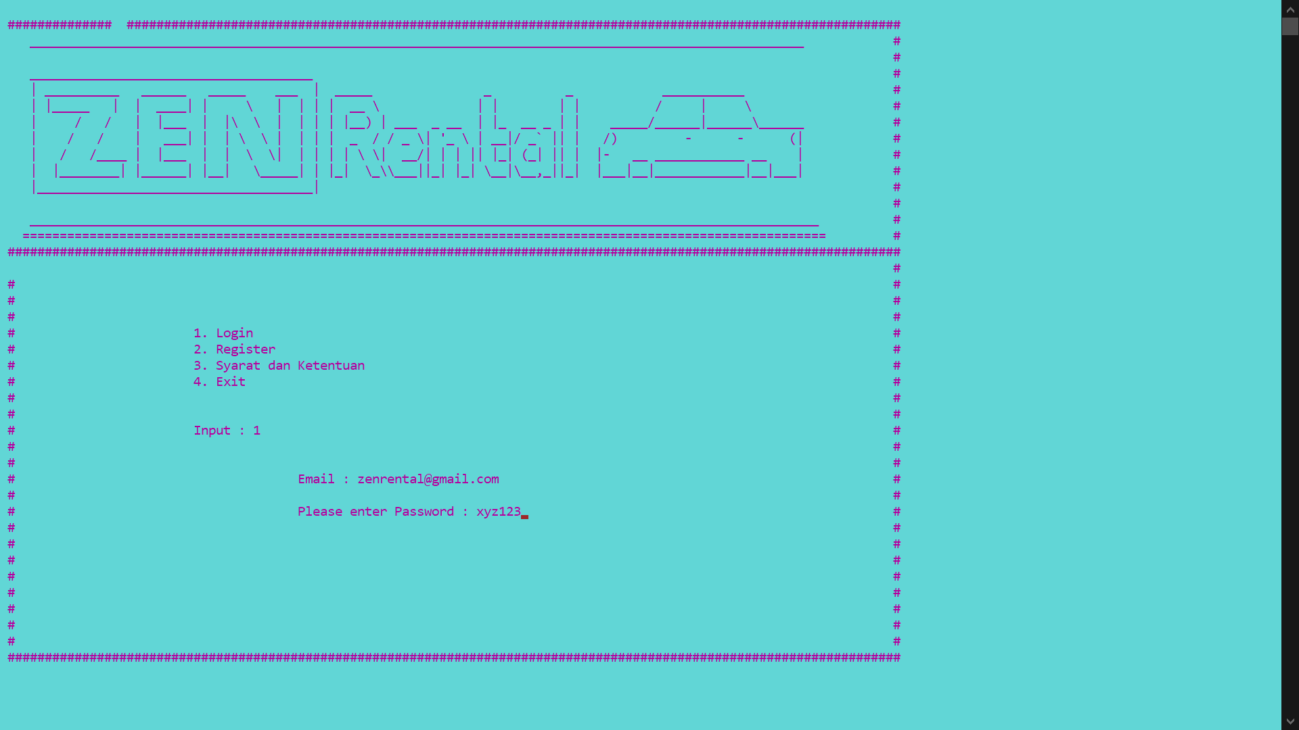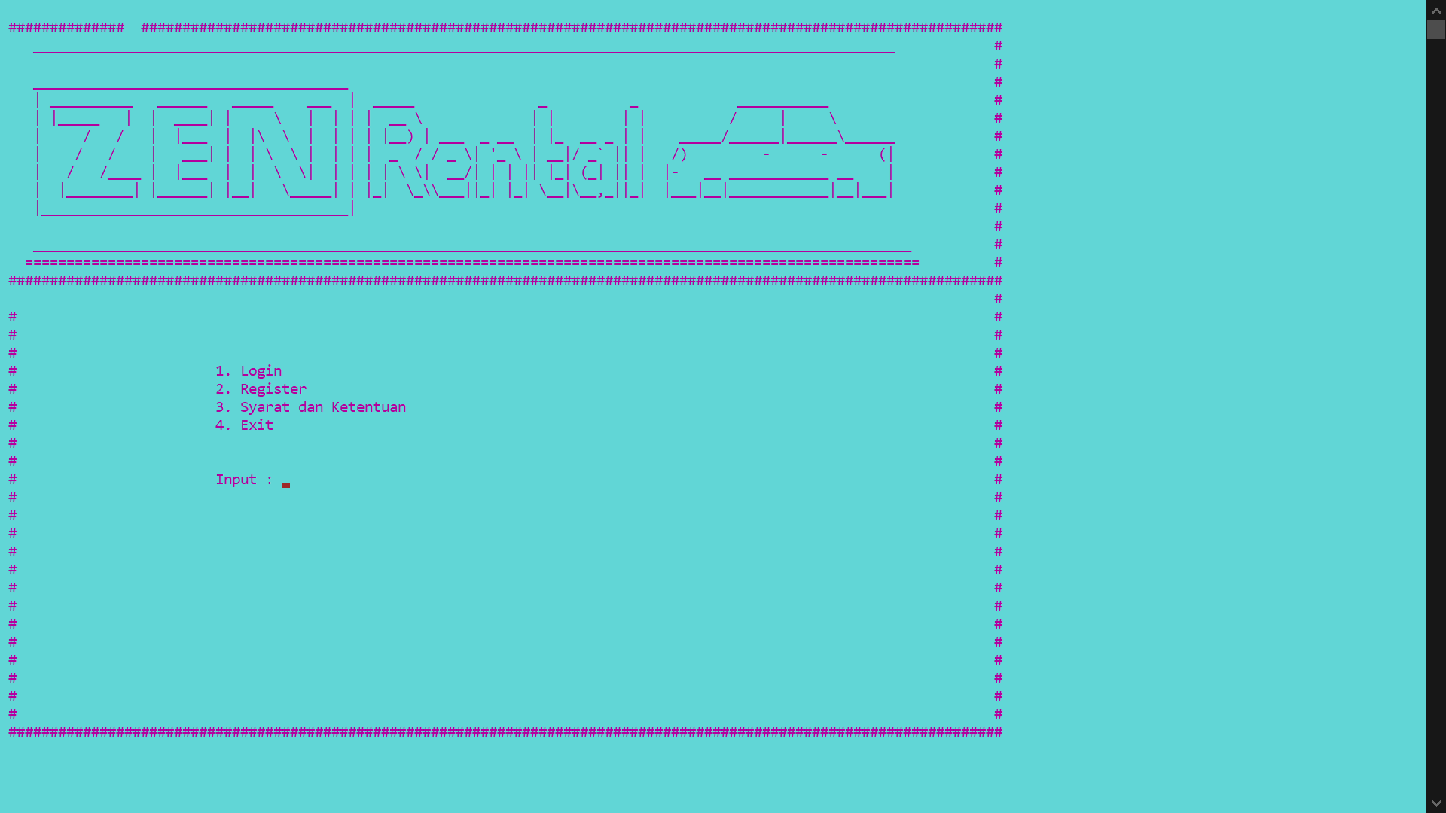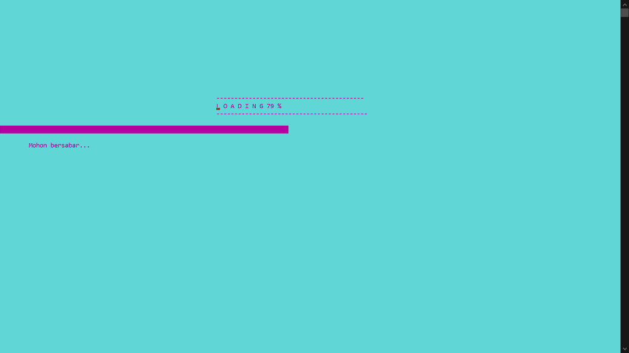**OUTPUT**

**OUTPUT**

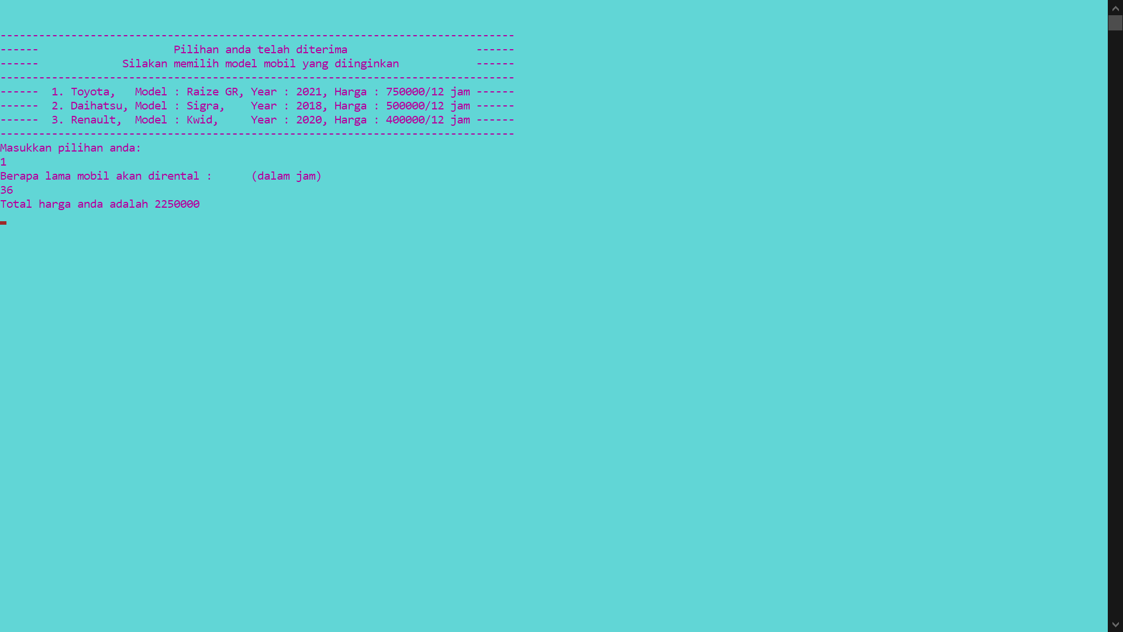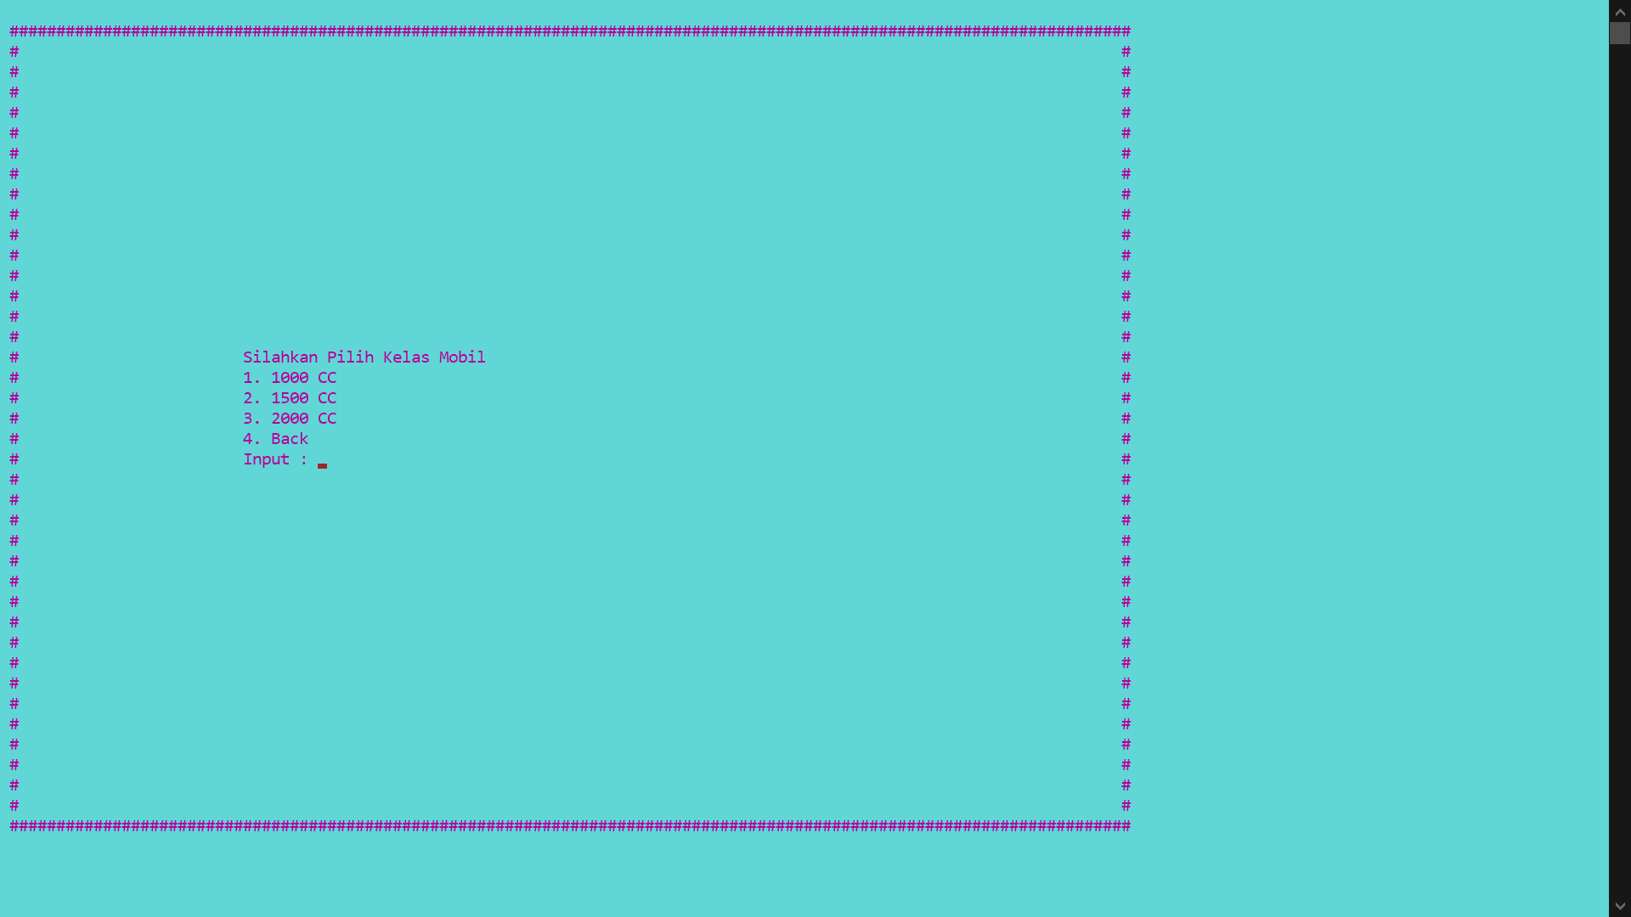

**OUTPUT**

